Chapter 9, Solution 82.

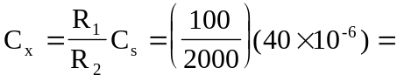 2 F

